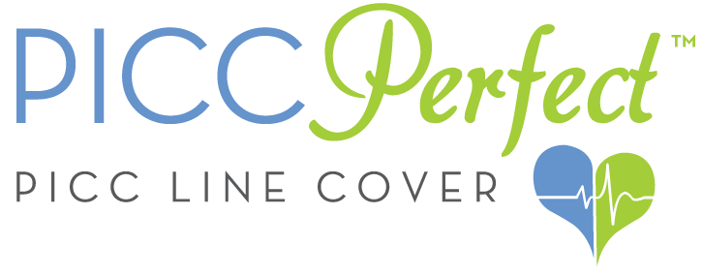

**Table of Contents**

**Executive Summary 2**

**PICC Line Industry Analysis 4**

**The Intravenous Market 5**

**Marketing Plan 7**

**Operations Plan 8**

**Finances 9**

*Funding Sources* 9

*Financial Plan* 10

**The PICCPerfect Team 10**

**Exhibits 12**

*The components of this business plan have been submitted on a confidential basis. Please do not store, copy, or distribute without permission.*

Executive Summary

PICCPerfect creates after-market medical accessories for patients going through long-term treatment. Our first product is the PICCPerfect PICC line cover, which allows patients to safely and securely protect their PICC line. Our covers are antimicrobial, moisture wicking, machine washable, and contain 4-way stretch. PICCPerfect's products are fashionable medical accessories that are made in the USA.

With its functional and fashionable medical accessories, PICCPerfect adds confidence to the lives of chronically ill patients. PICC lines are peripherally inserted central catheters that function as a permanent IV treatment. PICC lines disperse medication directly into the heart through a catheter that is typically inserted through a vein in the arm; a piece of the line extends outside of the arm for access to insert medication. PICC lines are used to treat a variety of chronic illnesses, including cancer and Lyme disease, as well as other medical conditions. Over 2 million PICC lines are inserted every year in the Unites States alone; this is a $7 billion market that is expected to grow to $9 billion by 2016 due to ObamaCare and increased health services.

Currently, PICCPerfect has produced its first round of manufacturing in Los Angeles, California. PICCPerfect is selling on Amazon, Etsy, PICCPerfect.com, and in four wholesale locations in the North East of the United States. The team has been attending nursing conferences in order to increase brand awareness, with a goal of having IV nurses recommending our products to patients. PICCPerfect also has a patient sponsorship program, where people can buy PICC line covers and PICCPerfect will donate them to patients in need. To date, 10% of our sales have been donated to patients in need.

PICCPerfect is currently prototyping children’s sizes, as well as a protective medical shower sleeve because PICC lines cannot get wet. In PICCPerfect’s 6-12 month plan, medical backpacks, cane covers, cancer caps, and oxygen tank covers will also be produced. All products will be both stylish and functional, so as to facilitate treatment, and provide patients with an aspect of normalcy in their daily lives they often long for as they go through difficult medical situations.

CEO and CO-Founder Emily has been suffering from Severe Chronic Lyme Disease since 2007, and like most Lyme patients, it took her years to get diagnosed. Emily had a PICC line in her arm for six months delivering intensive IV medications to battle her Lyme disease. During her time with a PICC line, Emily wore a sock on her arm to protect it, which had been recommended by her nurse for lack of effective alternatives. Her line was pulled from her arm, the sock was not comfortable, and it made her self-conscious and depressed. She experimented with other PICC line protectors on the market, none of which she was satisfied with.

After she got her line removed, Emily was determined to make a difference in the lives of all chronically ill patients. Emily and her Co-Founder have personally invested almost $8,000 into PICCPerfect; moreover, the team has won Purdue’s The Big Sell Pitch Competition, MIT’s Beantown Throwdown, and Best Student Business Award from Babson College, all in the year 2015.

## PICC Line Industry Analysis

PICC lines are catheters in the form of long, thin, flexible tubes used to give medicines, fluids, [nutrients](http://www.webmd.com/a-to-z-guides/major-nutrients-in-food-topic-overview), or [blood](http://www.webmd.com/heart/anatomy-picture-of-blood) products over a long period of time, usually several weeks or more.[1] PICC line patients include those undergoing treatment for cancer, Lyme disease, chronic infections, Total Parenteral Nutrition, hyperemesis, staph infections, MERSA, and more.

While there are PICC line covers on the market, none of them combine function with fashion. From PICCPerfect’s market survey data, over 50 patient interviews and first-hand experience, many of the PICC line covers on the market do not fit as advertised; consumers find them to be too expensive, and they do not satisfy patients’ fashion needs. The majority of patients use a sock or Kerlix medical gauze, because they are economical options; however, users have reported them as uncomfortable, itchy, and subpar.

***PICCPerfect’s SWOT Analysis:***

**Strengths**:

* PICCPerfect is a functional alternative to the current market players, due to its superior fabric technology and product design over the competition.
* Fabric: moisture wicking, antimicrobial, machine washable, and 4-way stretch.
* Mentors/Advisors: Jonathan Rolt - Head Nurse at Boston Public Health; Jim Poss - Founder of Big Belly Solar and Modifi; Kim Miles - Miles in Heels Productions and NYLife Financial.
* Butler Venture Program, Summer Venture Accelerator Program at Babson College, and currently in the WIN Lab (Women Innovating Now Accelerator in Boston).
* The unique practical design has a two-way fold and hole within the lining to do treatment on the go with line security.
* Reinforced with medical grade elastic on each end of the product so the patient does not have to worry about the cover falling down.
* In the U.S> patent process
* Market Validation: Sold over 250 units sold in first 2 months of selling, 4 wholesale accounts, and recommended by nurses at major Boston hospitals. **$3,223.87 in revenue in 3 months**
* **Won**: Purdue’s Business competition, The Big Sell ($24,000 USD in prizes and cash), MIT’s Beantown Throwdown ($15,000+ in prizes), $2,000 in Babson College seed funding, Best Student Business at Babson College (#1 Entrepreneurship college in the world) and more.

**Weaknesses:**

* PICCPerfect’s core team is currently full time college students. While all members are working full time on the business, sometimes it is challenging to manage classwork and running a business
* Currently, PICCPerfect’s only product is the PICCPerfect PICC line cover. While the target market is very focused, PICCPerfect will be expanding to other stylish and functional after-market medical accessories in the 6-12 month plan. We will keep PICCPerfect the name of our PICC line covers, and the team is currently working with a branding strategist to come up with a new name for the company that allows for more products to be included into product mix.

**Opportunities:**

* PICCPerfect’s main opportunity is to take advantage of the gap in the market for a product that focuses on the security of the external tubing of the PICC line. Most products offer a single band design that does not help the line stay in place.
* Medical Dressings as Accessories: Many competitors claim to be stylish, but offer limited selections. There is an opportunity in the market for attractive medical dressings that are designed to be worn as accessories and still provide line security.

**Threats**:

* New Entrants: This market requires relatively small capital necessary to enter this market. Therefore, new entrants are a real threat to the industry. PICCPerfect is currently working with a patent lawyer. Simultaneously, we are putting a great effort on increasing awareness and creating a holistic brand around our products, in order to differentiate ourselves from our competitors.

**Direct Competition:** While no other company adds style and fashion into the mix as PICCPerfect does, there are several competitive offerings in the market today, including: Sleek Sleeve, Quick Sleeve, and Care + Wear.

**Indirect Competitors**: Stockinette (stretchy medical tubing), which is given out by hospitals, and homemade products, such as cut socks or knitted covers.

## The Intravenous Market Size

In 2014, $7.069 billion of revenue was made in the PICC line market. The market is expected to grow to $9.3 billion by 2016 due to increased medical services globally and ObamaCare in the USA. Moreover, by 2013, 2 million PICC lines were being inserted per year in the United States alone. The primary market for our PICC line covers are patients 12-80 years old who are being treated with a PICC line.

Primary Market: Adult patients (12 years and older) with medical conditions that require a PICC line for their treatment.

Secondary Market: Primary market, with the addition of children (0-12 years), depending on arm size, as well as patients that want a shower sleeve PICC line protector.

Horizon Market: Includes the primary and secondary market, and expansion to the international PICC line market through medical distribution companies and e-commerce. (PICCPerfect has already sent orders overseas through e-commerce). Other products will be introduced for chronically ill patients.

A) The Intravenous Market in the United States and Global. [2]

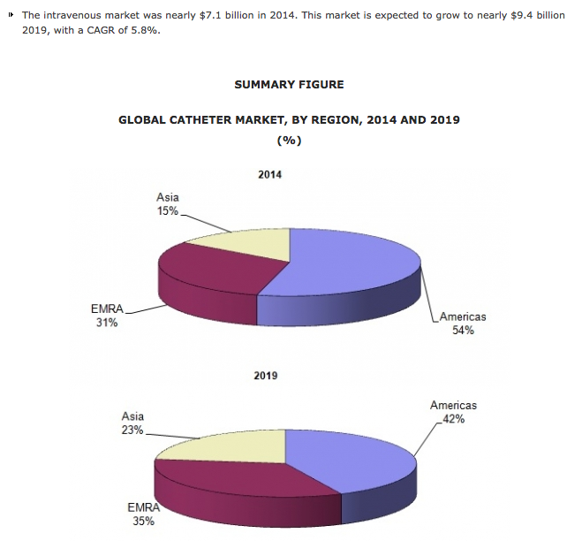

B) Average Cost to Dana Farber Hospital due to Unsuccessful PICC line insertion.[3]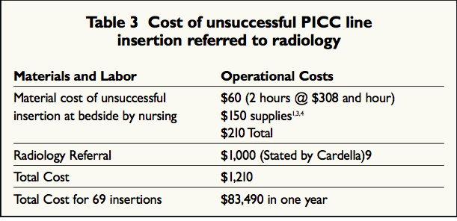

From PICCPerfect’s research, an exact number of PICC lines are placed per year in the United States had to be extrapolated from the current available data. Dana Farber, a leading PICC line expert for cancer treatments, reported that it cost them $1,200 to place a PICC. It’s important to note that every time a PICC line gets infected, or is pulled, the hospital has to re-incur the cost of insertion. The PICCPerfect PICC line covers reduce these costs for the hospitals by helping reduce complications with the line.

PICCPerfect’s plan is to expand into the chorically ill patients market, through the creation of various medical apparel and accessories that patients require and/or desire, with the intention of uplifing patients as a whole, while making them more comfortable.

As for PICCPerfect’s 6-12 month plan, we will first focus on the following products, which have been carefully selected after thorough market research and patients’ requests: PICC line covers is children’s sizes, stylish and functional medical backpacks, cancer caps, cane covers, and oxygen tank covers.

## Marketing Plan

The PICCPerfect team has been implementing and designing a integrated marketing plan in order to increase brand awareness, customer acquisition and retention. Firstly, PICCPerfect attends various nursing conferences and events per month in order to create brand awareness, to receive nurse feedback, and to meet strategic partners. INS (Infusion Nurses Society) and AVA (Association of Vascular Access) - MAVAN and MEVAN Chapters – are the two associations PICCPerfect has been working with.

Through these conferences, dinner meetings, and networking events, PICCPerfect educates its audience about Lyme disease, and its product. At the same time, PICCPerfect has been able to meet key industry players, which led the company to getting its first four wholesale deals at Boston Home Infusion, Olden’s Pharmacy, Newton-Wellesley Hospital Gift Shop, and Falk Surgical. PICCPerfect is currently in negotiations for three more wholesale accounts.

One of our key entry to market strategies is developing a strong relationship with infusion nurses. Infusion nurses recommend PICCPerfect’s products to patients, who can then order them online at PICCPerfect.com, Etsy, or Amazon. PICCPerfect has two teams of students at Purdue University and Institute for the International Education of Students (iesabroad.org) in Paris, France. The group at Purdue is helping with the company’s sales strategy and the team at IES is currently developing a cost effective marketing plan.

Another marketing tool is PICCPerfect’s online blog, called turning #LymeIntoLemonAid. This is a safe, empowering and supportive community where patients can share their stories about taking a difficult medical situation and turning it into a positive one. All chronic illness stories are welcomed, and thus far PICCPerfect has given voice to over 30 patients.

Moreover, PICCPerfect’s leads the ‘Sponsor A Patient Program’, by which customers can pay for a PICC line cover, and PICCPerfect will then donate it on their behalf to patients in need, who may not necessarily be able to afford it. To date, over 20 PICC line covers have been donated to the following organizations: Beth Israel Hospital in Boston, That Lucky Bracelet, The Super Hero Project and Invisiyouth Charity. This allows us to be socially responsible and at the same time increase our brand presence in these medical centers.

Furthermore, PICCPerfect recognizes the importance of media in our current business world; to date, the company has been featured in Boston Magazine Online, The Boston Globe: West, Babson Magazine, The Jewish Journal, Bostinno, U.S. News and World Report, Yahoo! News, Chronic Illness Coach, MIT’s Enterprise Forum, The Narragansett Times, and The Patch.

Finally, PICCPerfect also has a great social media presence; the team communicates in real time with over 1,000 followers on Instagram (PICC_Perfect), Twitter (@PICCPerfect), and Facebook (PICCPerfect). PICCPerfect posts informational content about interesting news and material in the medical industry, as well as inspirational and motivational posts for the #spoonies[4] community.

## Operations Plan

PICCPerfect is vertically integrated. The company’s operations are concerned with the design and production of PICCPerfect products – aftermarket medical accessories. This will leverage the team’s design capabilities, while allowing PICCPerfect to avoid significant regulations in the medical industry surrounding medical equipment. PICCPerfect’s operations include the design of proprietary products, patterns, and materials in cooperation with a selected manufacturer, as well as the sale and distribution of the aforementioned products. PICCPerfect currently manages all of the wholesale accounts and online orders.

***Scope of Operations***

Designing: Currently done in cooperation with the Elite Fashion Group, PICCPerfect’s manufacturer based in Los Angeles, California.

Printing: Elite Fashion Group performs the sublimation of the fabric, while PICCPerfect performs the design of patterns and products.

Manufacturing: Outsourced to the Elite Fashion Group.

Legal: Outsourced to various legal consultants (Over $15,000 in legal services won to date).

Sales/Distribution: Performed by PICCPerfect, through PICCPerfect.com, Amazon, Etsy, and wholesale accounts.

Location: As a part of the Butler Venture Accelerator Program, PICCPerfect currently operates out of an office space at Wellesley, MA. Inventory and all operational activities are carried out in this location. The legal business address for PICCPerfect is 45 Catherine Street, Newport, RI 02840. HumLev Enterprises LLC, DBA “PICCPerfect” is registered in Delaware, USA.

## Finances

### *Funding Sources*

**Self-Funded:** PICCPerfect is owned and operated by HumLev Enterprises LLC (a Delaware Corporation) with a business license from Rhode Island. The business is currently self-funded. Yousef and Emily, both college students, have invested over $8,500 of their own funds to date. PICCPerfect has set up a small business account with Bank of America and an EIN Number. Emily owns 51% of the company and Yousef owns 49%.

**Kickstarter:** PICCPerfect ran a 30-day Kickstarter campaign with a goal of $10,000. The team raised $13,200, funding the campaign by 132%, which paid for the first round of manufacturing.

**Seed Funding:** PICCPerfect has been awarded $2,000 from the Babson College Seed Fund.

**Purdue’s The Big Sell:** $3,000 cash, $3,000 in legal services, $3,000 in accounting services, $3,000 in marketing services, $3,000 in volunteered advisory services, $4,500 office space, $3,000 in business plan assistance from Purdue’s team.

**MIT’s Beantown Throwdown:** $12,000 in legal services, $4,000 in office space, and $1,000 in digital marketing services.

### *Financial Data:*

The following tables provide a break of what our revenue, costs of goods sold, and profit per unit, for both the black PICC line cover and the patterned fabric, in the different sales channels we are selling.

As evidenced, our products are profitable in all channels; however, not enough to sustain a long-term profitable business. The main driver for this low profitability is our high manufacturing costs.

In order to reduce these costs, we are going to move to a manufacturer located in Rhode Island, which is closer to our headquarters, hence better operationally. At the same time, the new manufacturer has quoted us a manufacturing cost of $9 dollars per unit. This change will signify an increase in the company’s profitability. Additionally, the sales team will be working aggressively towards increasing wholesale deals.

|  |  |  |  |  |
| --- | --- | --- | --- | --- |
| **Etsy** | |  | **Amazon** | |
| Revenue per unit | $25.99 |  | Revenue per unit | $25.99 |
| Packaging Materials | $0.37 |  | Packaging Materials | $0.37 |
| Shipping | $2.64 |  | Shipping | $2.64 |
| Fee (3.5%) | $0.88 |  | Amazon Fee (15%) | $4.35 |
| Total | $22.10 |  | Total | $18.63 |
| - Manufacturing cost |  |  | - Manufacturing cost |  |
| Profit per Black Cover | **$9.55** |  | Profit per Black Cover | **$6.08** |
| Profit per Pattern Cover | **$7.80** |  | Profit per Pattern Cover | **$4.33** |
|  |  |  |  |  |
|  |  |  |  |  |
| **Stripe (Wix - www.piccperfect.com)** | |  | **Paypal** | |
| Revenue per unit | 25.99 |  | Revenue per unit | 25.99 |
| Packaging Materials | $0.37 |  | Packaging Materials | $0.37 |
| Shipping | $2.64 |  | Shipping | 2.64 |
| Fees (2.9% +0.30) | $1.05 |  | Fees (2.9% +0.30) | 1.05 |
| Total | $21.93 |  | Total | $21.93 |
| **- Manufacturing cost** |  |  | **- Manufacturing cost** |  |
| Profit per Black Cover | **$9.38** |  | Profit per Black Cover | **$9.38** |
| Profit per Pattern Cover | **$7.63** |  | Profit per Pattern Cover | **$7.63** |
|  |  |  |  |  |
|  |  |  | **PICCPerfect's Unit Cost of Sale** | |
|  |  |  | Black | Pattern |
|  |  |  | **$12.55** | **$14.30** |

## Revenue to Date (October 29, 2015): $3,223.87 🡪 three months of selling

## The PICCPerfect Team

** Emily: CEO and Co-Founder**

Emily is passionate about helping people with chronic illness to feel “PICCed Up” through her working at PICCPerfect. She is particularly passionate about educating people about Lyme disease, as she has suffered from the disease for the past 8 years. Concentration: Technology, Entrepreneurship, and Design. Previous Work Experience: Veems (App) in Israel (Community Manager), Newport Harbor Corporation (Corporate Sponsorship Intern), Roxy/Quicksilver (Intern), Smith Optics (Intern), O’Neill (Lead Assistant at GL Sales).

 **Yousef: CFO and Co-Founder**

Yousef wanted to start PICCPerfect in order to help people have a more positive medical treatment experience. Concentration: Entrepreneurship, Finance, and Accounting. *Currently working full time at Wafra Investments in New York City, NY in order to gain additional financial experience and to inject capital into the business as well as working part-time on PICCPerfect.

** Maria del Mar: CMO and Founding Member**

Maria became a member of the PICCPerfect team because she was inspired by Emily’s struggle with Lyme disease and her desire to make a difference in the lives of chronically ill patients. Concentration: Technology Entrepreneurship and Design*.* Previous Work Experience: Beauty Shop Salon (Administrative Assistant and Receptionist), and College Connect (CFO of a student Run Business).

**Mentors/Advisors:**

**Jonathan Rolt:** Head PICC nurse at Boston Public Health

**Jim Poss:** Founder of Big Belly Solar and CEO of Modifi

**Kim Miles:** Financial Services Professional with NYLIFE Securities and CEO/Founder of Miles In Heels Productions

## Exhibits

**Exhibit 1:** Pictures of external appearance of a PICC line.

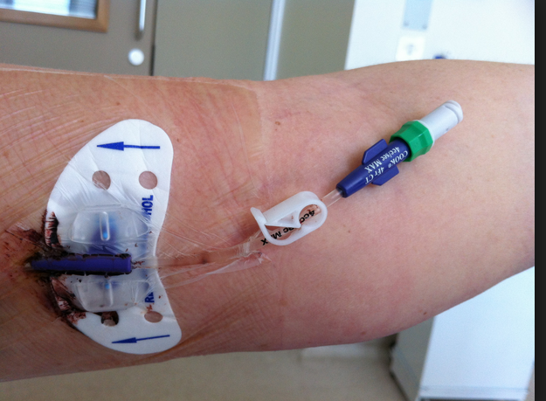 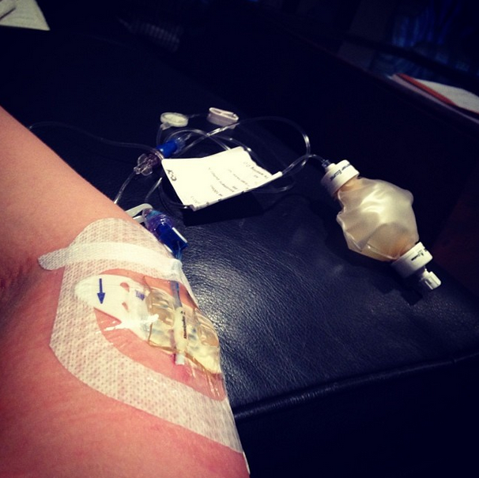

**Exhibit 2:** Diagram of how a PICC line is inserted in a person’s arm and reaches the heart.

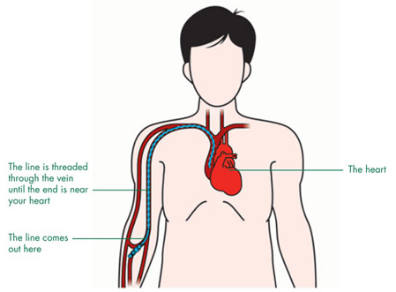

**Exhibit 4:** Kerlix’s gauze – one of the options patients have to recur to protect the lines.

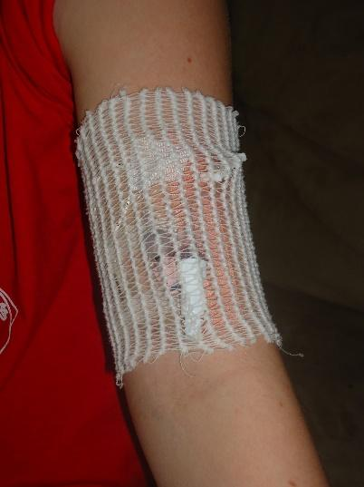

**Exhibit 5:** PICCPerfect’s PICC line cover in the current three patterns.

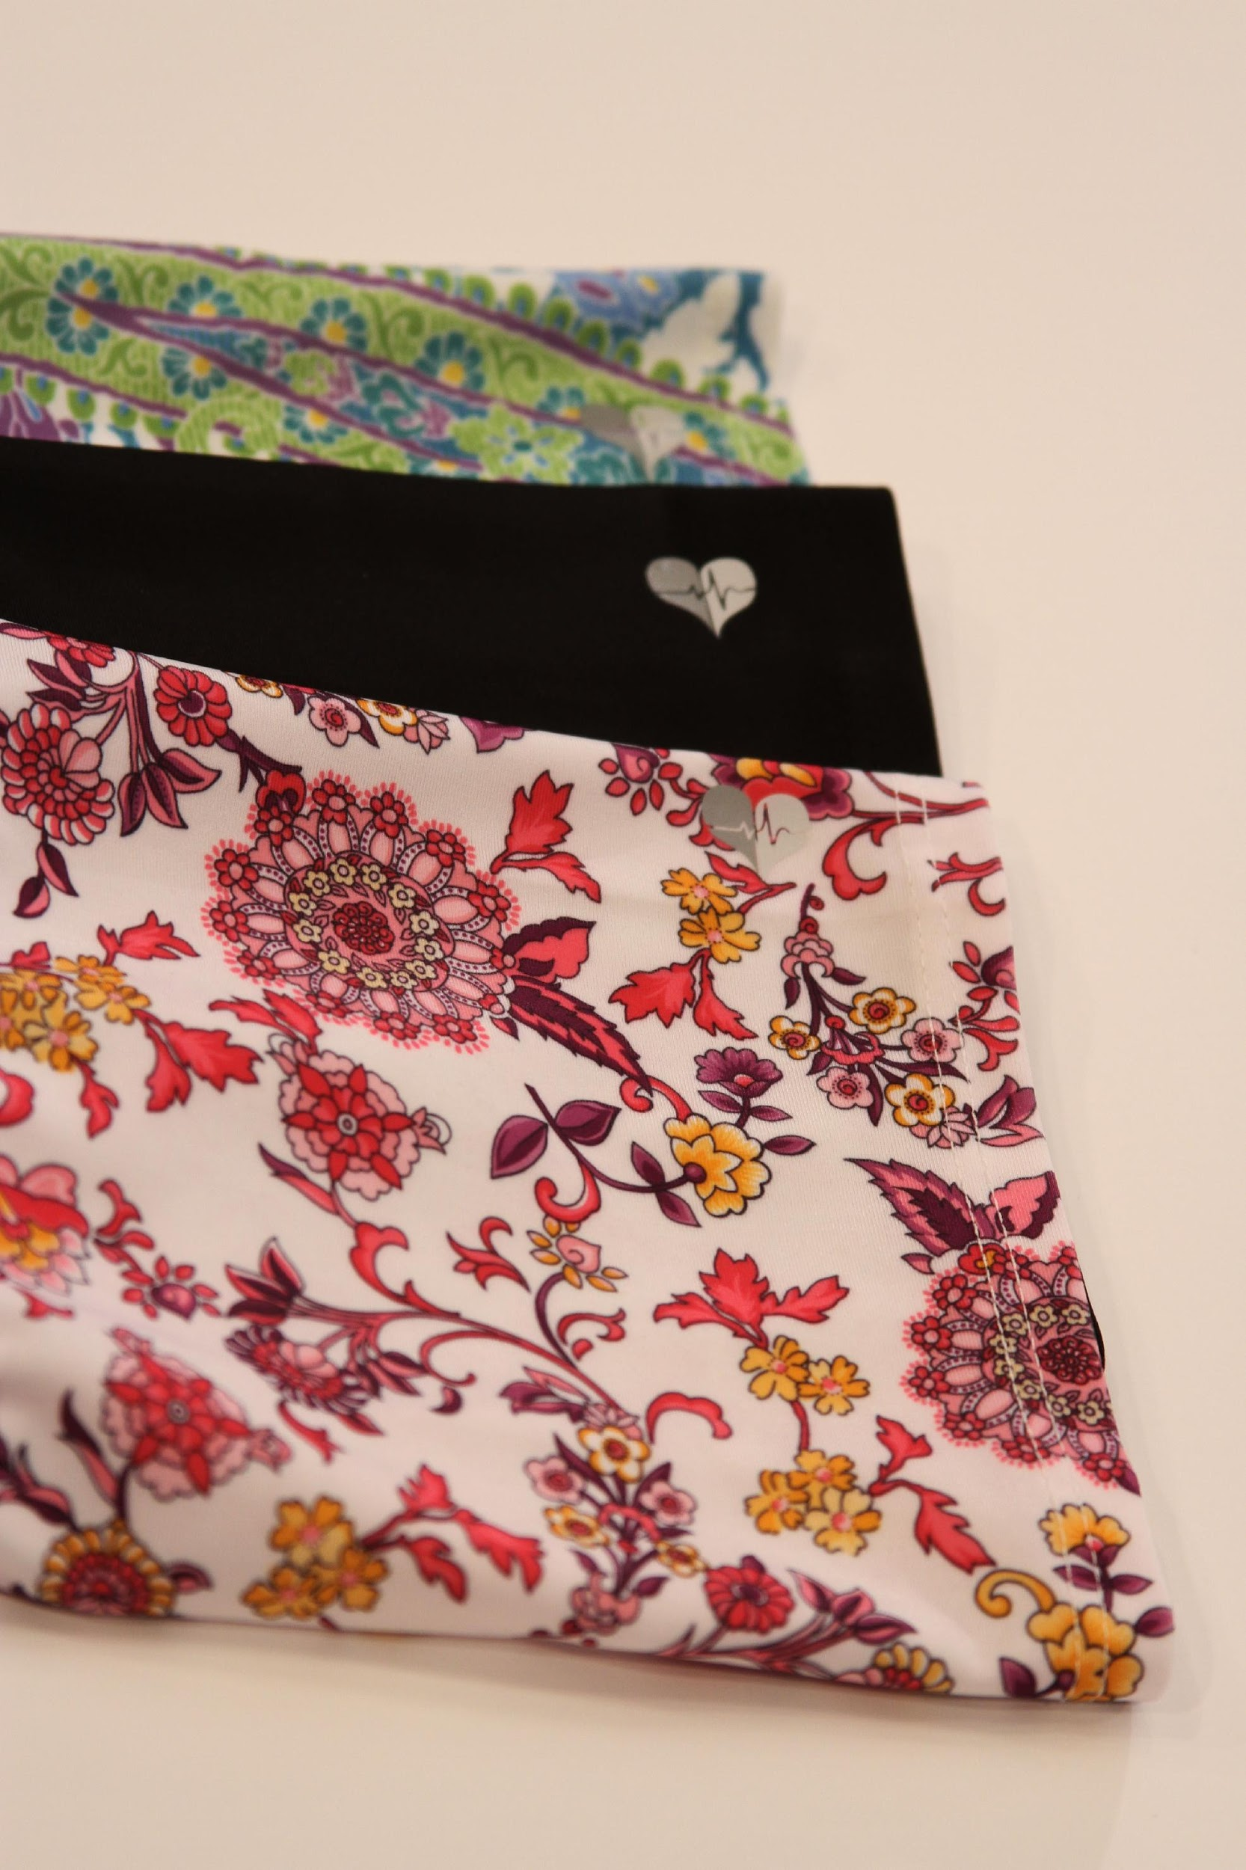 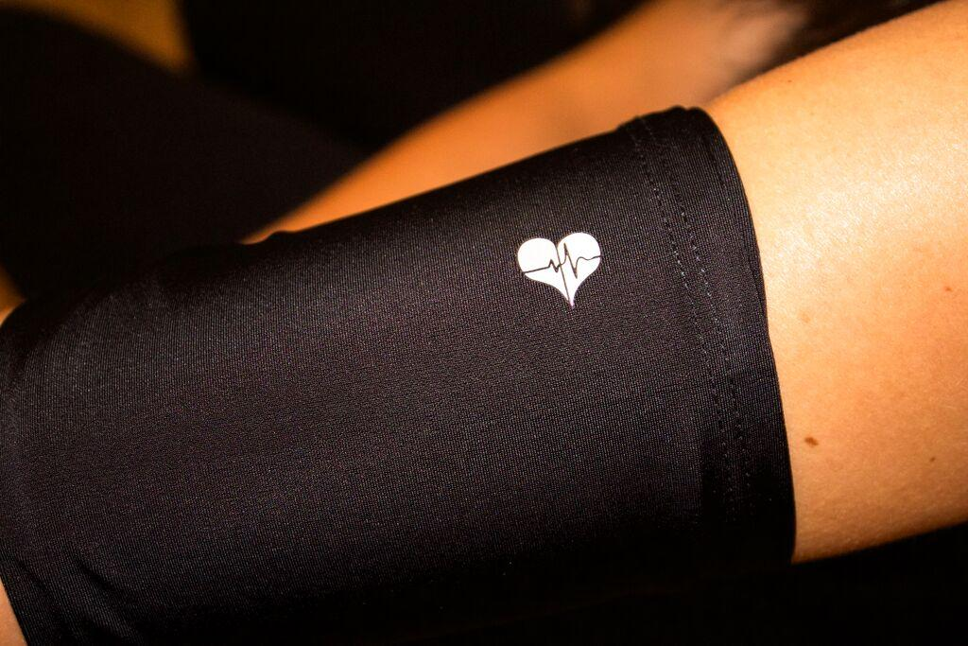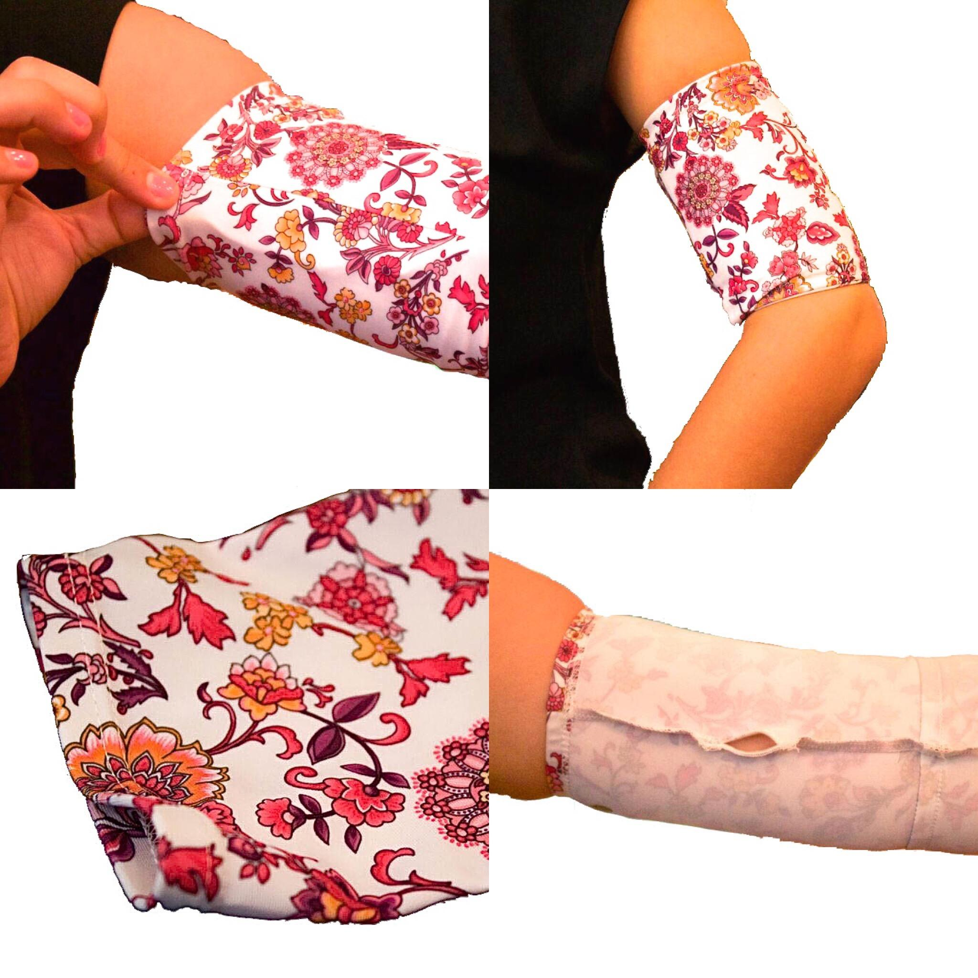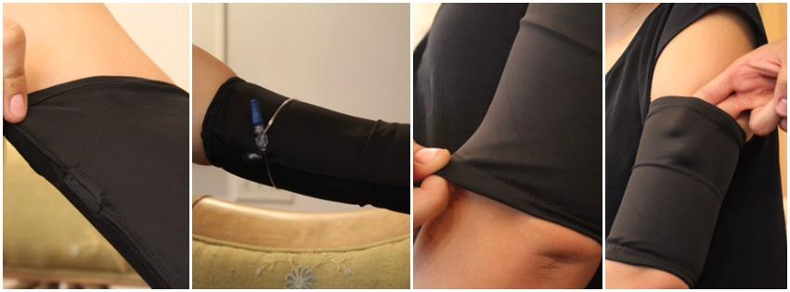

**Exhibit 6:** PICCPerfect’s happy customers wearing their practical and fashionable PICC line covers.

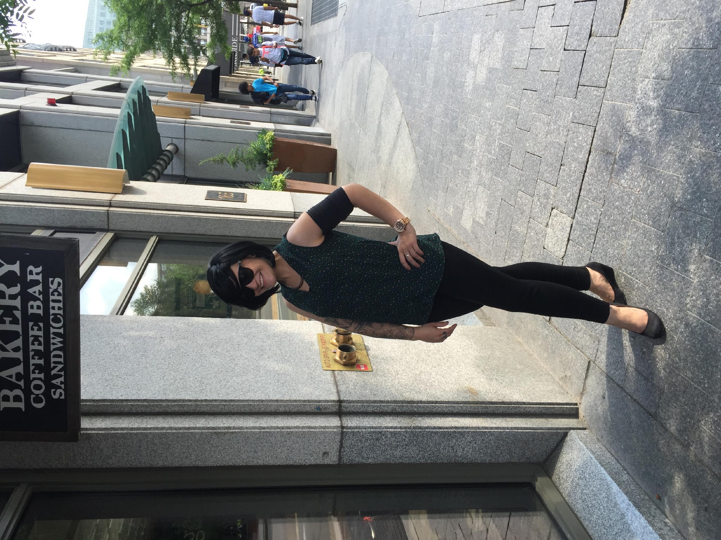 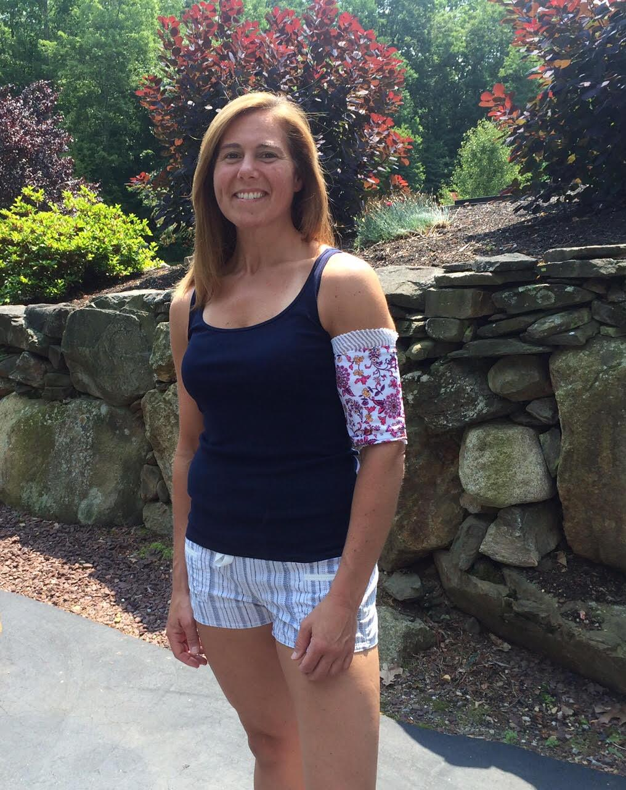

1. "Central Venous Catheters-Topic Overview." WebMD. WebMD, 2015. Web. 28 Oct. 2015.
2. Lehr, Peggy. "Global Market for Catheters." *BCC*. BCC Research, Mar. 14. Web. 6 Oct. 2015
3. Dana Farber. *Annual Report on PICC Lines.* 2014.
4. Current social media term referring to the chronically ill patients.